11. Multithreading Using C
AIM
To illustrate the concept of multithreading using the POSIX thread library.
PROGRAM
#include <stdio.h>
#include <pthread.h>
void *task(void *arg)
{
int n = *(int *)arg;
printf("Thread %d is running\n", n);
return NULL;
}
int main()
{
pthread_t t1, t2;
int a = 1, b = 2;
pthread_create(&t1, NULL, task, &a);
pthread_create(&t2, NULL, task, &b);
pthread_join(t1, NULL);
pthread_join(t2, NULL);
printf("Both threads completed.\n");
return 0;
}
SAMPLE OUTPUT
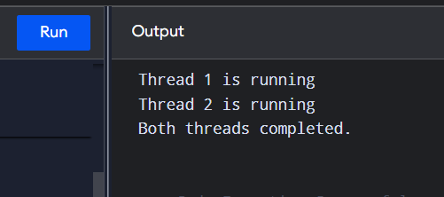
RESULT
Thus, multiple threads were successfully created and executed using the POSIX thread library.

12. Dining Philosophers Problem
AIM
To implement and simulate the Dining Philosophers problem using C and demonstrate synchronization using semaphores.
PROGRAM
#include <stdio.h>
#include <pthread.h>
#include <semaphore.h>
#include <unistd.h>
#define N 5
sem_t fork_sem[N];
void *philosopher(void *arg)
{
int id = *(int *)arg;
int left = id;
int right = (id + 1) % N;
printf("Philosopher %d is thinking\n", id);
sleep(1);
if (id % 2 == 0)
{
sem_wait(&fork_sem[left]);
sem_wait(&fork_sem[right]);
}
else
{
sem_wait(&fork_sem[right]);
sem_wait(&fork_sem[left]);
}
printf("Philosopher %d is eating\n", id);
sleep(1);
sem_post(&fork_sem[left]);
sem_post(&fork_sem[right]);
printf("Philosopher %d finished eating\n", id);
return NULL;
}
int main()
{
pthread_t threads[N];
int id[N];
int i;
for (i = 0; i < N; i++)
sem_init(&fork_sem[i], 0, 1);
for (i = 0; i < N; i++)
{
id[i] = i;
pthread_create(&threads[i], NULL, philosopher, &id[i]);
}
for (i = 0; i < N; i++)
pthread_join(threads[i], NULL);
for (i = 0; i < N; i++)
sem_destroy(&fork_sem[i]);
return 0;
}

SAMPLE OUTPUT
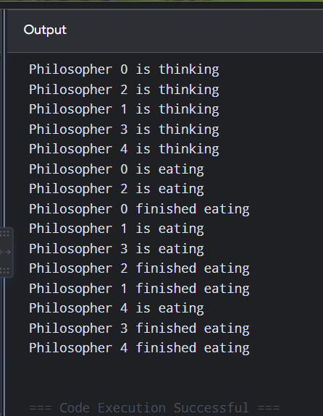
RESULT
Thus, the Dining Philosophers problem was successfully simulated using threads and semaphores.

13. Memory Allocation Strategies
AIM
To implement various memory allocation strategies such as First Fit, Best Fit, and Worst Fit using C.
PROGRAM
#include <stdio.h>
int alloc[20], i, j, worst;
for (i = 0; i < n; i++)
alloc[i] = -1;

for (i = 0; i < n; i++)
{
worst = -1;

for (j = 0; j < m; j++)
{
if (block[j] >= process[i])
{
if (worst == -1 || block[j] > block[worst])
worst = j;
}
}

if (worst != -1)
{
alloc[i] = worst;
block[worst] -= process[i];
}
}

printf("\nWorst Fit:\n");
for (i = 0; i < n; i++)
{
if (alloc[i] != -1)
printf("Process %d -> Block %d\n",
i + 1, alloc[i] + 1);
else
printf("Process %d -> Not Allocated\n", i + 1);
}
}

int main()
{
int block1[20], block2[20], block3[20];
int process[20], m, n, i;

printf("Enter number of memory blocks: ");
scanf("%d", &m);

printf("Enter block sizes:\n");
for (i = 0; i < m; i++)
{
scanf("%d", &block1[i]);
block2[i] = block3[i] = block1[i];
}

printf("Enter number of processes: ");
scanf("%d", &n);

printf("Enter process sizes:\n");
for (i = 0; i < n; i++)
scanf("%d", &process[i]);

firstFit(block1, m, process, n);
bestFit(block2, m, process, n);
worstFit(block3, m, process, n);

return 0;
}
SAMPLE INPUT
Enter number of memory blocks: 5
Enter block sizes:
100 500 200 300 600
Enter number of processes: 4
Enter process sizes:
212 417 112 426
SAMPLE OUTPUT
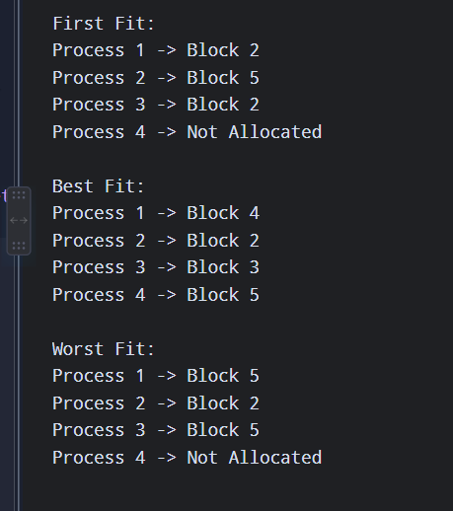
RESULT
Thus, First Fit, Best Fit, and Worst Fit memory allocation strategies were successfully implemented.

14. Single-Level Directory
AIM
To implement a single-level directory structure using C.
PROGRAM
#include <stdio.h>
#include <string.h>

int main()
{
char files[20][30];
int n = 0, choice, i;
char name[30];

while (1)
{
printf("\n1. Create File");
printf("\n2. Display Files");
printf("\n3. Delete File");
printf("\n4. Exit");
printf("\nEnter choice: ");
scanf("%d", &choice);

switch (choice)
{
case 1:
printf("Enter file name: ");
scanf("%s", name);

strcpy(files[n], name);
n++;

printf("File created.\n");
break;

case 2:
printf("\nFiles in directory:\n");

for (i = 0; i < n; i++)
printf("%s\n", files[i]);

break;

case 3:
printf("Enter file name to delete: ");
scanf("%s", name);

for (i = 0; i < n; i++)
{
if (strcmp(files[i], name) == 0)
{
strcpy(files[i], files[n - 1]);
n--;
printf("File deleted.\n");
break;
}
}
break;

case 4:
return 0;

default:
printf("Invalid choice.\n");
}
}
}
SAMPLE INPUT/OUTPUT
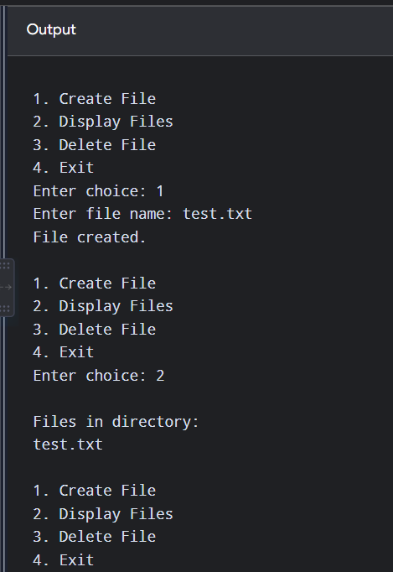
RESULT
Thus, the single-level directory structure was successfully implemented.

15. Two-Level Directory
AIM
To implement a two-level directory structure using C.
PROGRAM
#include <stdio.h>
strcpy(users[i].files[users[i].count],
filename);

users[i].count++;

printf("File created.\n");
break;
}
}
}
else if (choice == 3)
{
for (i = 0; i < userCount; i++)
{
int j;

printf("\nUser: %s\n", users[i].username);

for (j = 0; j < users[i].count; j++)
printf(" %s\n", users[i].files[j]);
}
}
else if (choice == 4)
{
return 0;
}
}
}

SAMPLE INPUT/OUTPUT
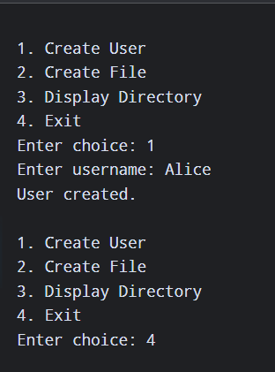
RESULT
Thus, the two-level directory structure was successfully implemented.

16. Random Access File for Employee Details
AIM
To implement a random access file for storing and processing employee details using C.
PROGRAM
#include <stdio.h>

for (int i = 0; i < n; i++)
{
printf("Enter ID, Name and Salary: ");
scanf("%d %s %f",
&emp.id, emp.name, &emp.salary);

fwrite(&emp, sizeof(emp), 1, fp);
}

printf("\nEnter employee position to access: ");
scanf("%d", &pos);

fseek(fp, (pos - 1) * sizeof(emp), SEEK_SET);

if (fread(&emp, sizeof(emp), 1, fp) == 1)
{
printf("\nEmployee Details\n");
printf("ID : %d\n", emp.id);
printf("Name : %s\n", emp.name);
printf("Salary : %.2f\n", emp.salary);
}
else
{
printf("Employee not found.\n");
}

fclose(fp);

return 0;
}
SAMPLE INPUT
Enter number of employees: 3

Enter ID, Name and Salary: 101 Arun 25000
Enter ID, Name and Salary: 102 Ravi 30000
Enter ID, Name and Salary: 103 Kumar 35000

Enter employee position to access: 2
SAMPLE OUTPUT
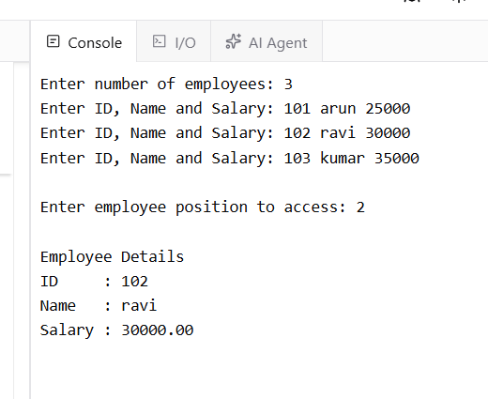
RESULT
Thus, random access of employee records was successfully implemented using fseek() and file handling functions.

17. Banker's Algorithm
AIM
To implement the Banker's algorithm for deadlock avoidance using C.
PROGRAM
#include <stdio.h>
need[i][j] = max[i][j] - alloc[i][j];

while (count < n)
{
found = 0;

for (i = 0; i < n; i++)
{
if (!finish[i])
{
int possible = 1;

for (j = 0; j < m; j++)
{
if (need[i][j] > avail[j])
{
possible = 0;
break;
}
}

if (possible)
{
for (k = 0; k < m; k++)
avail[k] += alloc[i][k];

safe[count++] = i;
finish[i] = 1;
found = 1;
}
}
}

if (!found)
{
printf("\nSystem is NOT in a safe state.\n");
return 0;
}
}

printf("\nSystem is in a SAFE state.\n");

printf("Safe sequence: ");

for (i = 0; i < n; i++)
printf("P%d ", safe[i]);

printf("\n");

return 0;
}
SAMPLE INPUT
Enter number of processes: 5
Enter number of resources: 3
Enter Allocation Matrix:
0 1 0
2 0 0
3 0 2
2 1 1
0 0 2
Enter Maximum Matrix:
7 5 3
3 2 2
9 0 2
2 2 2
4 3 3

Enter Available Resources:
3 3 2
SAMPLE OUTPUT
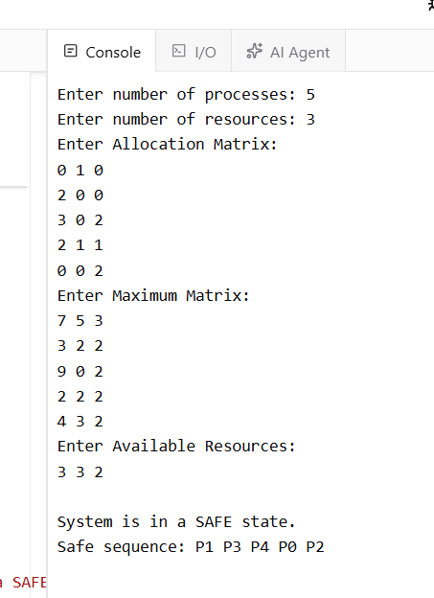
RESULT
Thus, the Banker's algorithm was successfully implemented and the system's safe sequence was determined.

18. Producer–Consumer Problem Using Semaphores
Aim
To write a C program to simulate the Producer–Consumer problem using semaphores.
Program
#include <stdio.h>
int buffer[SIZE];
int in = 0, out = 0;

sem_t empty, full;
pthread_mutex_t mutex;

void *producer(void *arg)
{
int item;

for (int i = 1; i <= 5; i++)
{
item = i * 10;

sem_wait(&empty);
pthread_mutex_lock(&mutex);

buffer[in] = item;
printf("Producer produced: %d\n", item);
in = (in + 1) % SIZE;

pthread_mutex_unlock(&mutex);
sem_post(&full);
}

return NULL;
}

void *consumer(void *arg)
{
int item;

for (int i = 1; i <= 5; i++)
{
sem_wait(&full);
pthread_mutex_lock(&mutex);

item = buffer[out];
printf("Consumer consumed: %d\n", item);
out = (out + 1) % SIZE;

pthread_mutex_unlock(&mutex);
sem_post(&empty);
}

return NULL;
}

int main()
{
pthread_t p, c;

sem_init(&empty, 0, SIZE);
sem_init(&full, 0, 0);
pthread_mutex_init(&mutex, NULL);

pthread_create(&p, NULL, producer, NULL);
pthread_create(&c, NULL, consumer, NULL);

pthread_join(p, NULL);
pthread_join(c, NULL);

sem_destroy(&empty);
sem_destroy(&full);
pthread_mutex_destroy(&mutex);

return 0;
}
Sample Output
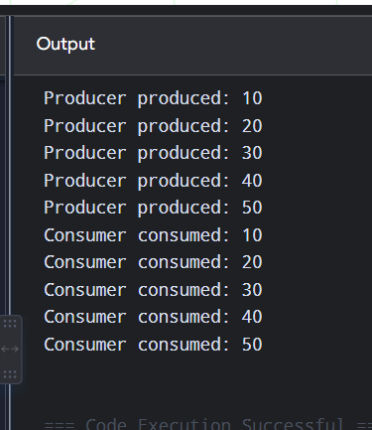
Result
Thus, the Producer–Consumer problem was successfully simulated using semaphores.

19. Process Synchronization Using Mutex Locks
Aim
To write a C program to implement process/thread synchronization using mutex locks.
Program
#include <stdio.h>

int main()
{
pthread_t t1, t2;

pthread_mutex_init(&mutex, NULL);

pthread_create(&t1, NULL, increment, (void *)1);
pthread_create(&t2, NULL, increment, (void *)2);

pthread_join(t1, NULL);
pthread_join(t2, NULL);

pthread_mutex_destroy(&mutex);

printf("\nFinal value of counter = %d\n", counter);

return 0;
}
Sample Output
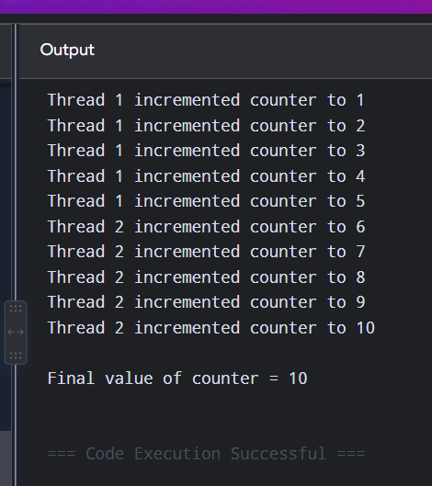
Result
Thus, process/thread synchronization was successfully implemented using mutex locks, preventing simultaneous access to the shared counter.
20. Reader–Writer Problem Using Semaphores
Aim
To write a C program to simulate the Reader–Writer problem using semaphores.
Program
#include <stdio.h>
#include <pthread.h>
#include <semaphore.h>

int data = 0;
int read_count = 0;

sem_t mutex;
sem_t write_lock;

void *reader(void *arg)
{
int id = *(int *)arg;

sem_wait(&mutex);
read_count++;

if (read_count == 1)
sem_wait(&write_lock);

sem_post(&mutex);

printf("Reader %d is reading data = %d\n", id, data);

sem_wait(&mutex);
read_count--;

if (read_count == 0)
sem_post(&write_lock);

sem_post(&mutex);

return NULL;
}

void *writer(void *arg)
{
int id = *(int *)arg;

sem_wait(&write_lock);

data += 10;
printf("Writer %d is writing data = %d\n", id, data);

sem_post(&write_lock);

return NULL;
}

int main()
{
pthread_t r1, r2, w1;
int id1 = 1, id2 = 2, id3 = 1;

sem_init(&mutex, 0, 1);
sem_init(&write_lock, 0, 1);

pthread_create(&r1, NULL, reader, &id1);
pthread_create(&r2, NULL, reader, &id2);
pthread_create(&w1, NULL, writer, &id3);

pthread_join(r1, NULL);
pthread_join(r2, NULL);
pthread_join(w1, NULL);

sem_destroy(&mutex);
sem_destroy(&write_lock);

printf("\nFinal data = %d\n", data);

return 0;
}
Sample Output
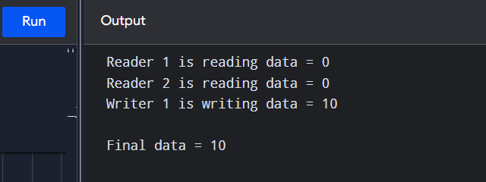
Result
Thus, the Reader–Writer problem was successfully simulated using semaphores, allowing multiple readers to access shared data while ensuring exclusive access for writers

